Biography – Sir David Carter, National Schools Commissioner

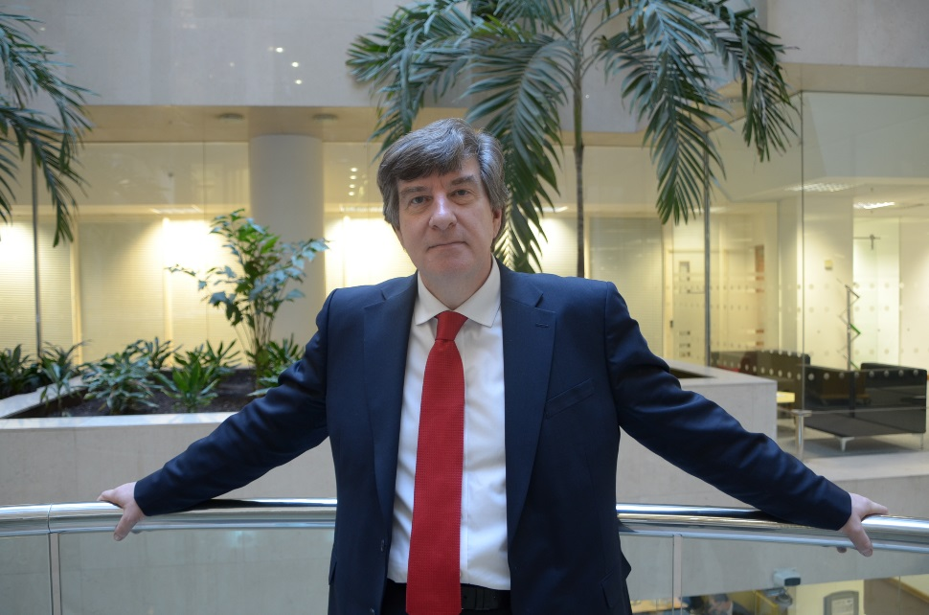

I was the product of a comprehensive school in South Wales, and was the first member of my family to go to university. Making a difference to the lives of children similar to me has motivated me throughout my career.

I became the National Schools Commissioner (NSC) in February 2016 having had the majority of my previous leadership experience in the school system. As NSC, I lead a team that oversees the 6500 academies in England and intervenes with them when performance standards fall. Our focus is on building capacity so that the trusts that run them can sustain improvement over time.

Before I joined the Civil Service I was a CEO in a multi academy trust in Bristol. The scale of this challenge where I was responsible for 12 schools, 5000 children and 1200 staff was excellent preparation for my current role where my leadership span of control extends across eight regional offices. The majority of the schools that we sponsored had failed for years and my experience of leading rapid improvement in disadvantaged communities informs my thinking in my current role.

I have learned that the best strategies need teams to be well supported and intelligently held to account. As NSC I expect high performance from my RSC team, and I have built our strategy around two priorities. Firstly, growing the capacity of the school system to support weaker schools, and secondly, improving the system so that weaker schools get stronger and stronger schools become world class.

